**Problem B: Billiard bounces**

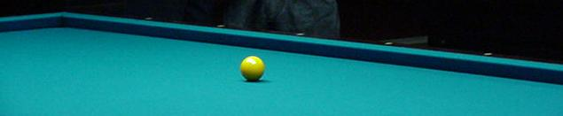

On a billiard table with a horizontal side **a** inches long and a vertical side **b** inches long, a ball is launched from the middle of the table with initial velocity **v** inches per second and launching angle **A** between 0 and 90 degrees measured counter-clockwise from the horizontal.

Assume that collisions with a side are elastic (no energy loss), and thus the absolute value of a velocity component of the ball parallel to each side remains unchanged after the bounce. However, due to friction the ball decelerates at a constant rate and comes to a full stop after **s** > 0 seconds. Assume the ball has a radius of zero. Remember that, unlike pool tables, billiard tables have no pockets.

How many times will the ball touch the vertical walls and how many times will the ball touch the horizontal walls? If the ball touches a corner it means that it touched both a horizontal and a vertical wall.

Input consists of a sequence of lines, each containing five nonnegative integers separated by whitespace. The five numbers are: **a** > 0, **b** > 0, **v** > 0, 0 ≤ **A** ≤ 90, and **s** > 0, respectively.

Input is terminated by a line containing five zeroes.

For each input line except the last, output a line containing two integer numbers separated by a single space. The first number says how many times the ball touched vertical walls and the second number says how many times the ball touched horizontal walls.

**Sample Input**

100 50 10 90 10

100 50 10 0 40

100 100 10 45 15

100 50 10 1 200

100 50 10 89 200

100 50 10 45 1000

100 100 10 30 200

0 0 0 0 0

**Sample Output**

0 1

2 0

1 1

10 0

0 20

35 71

9 5